Name : Martin James Wanzetse
Adm no :BBIT/2024/58201
Course:Business Information Technology
Lecturers Name:Michael Nyoro

Contents
Database intergration 3
Php+MySql connection 3
CRUD OPERATIONS 4
1.Create(Insert)operation 4
Read operations 5
Update operations 6
Delete operations 7

Database intergration

Php+MySql connection
-The following code demonstrates the connection between php and MySql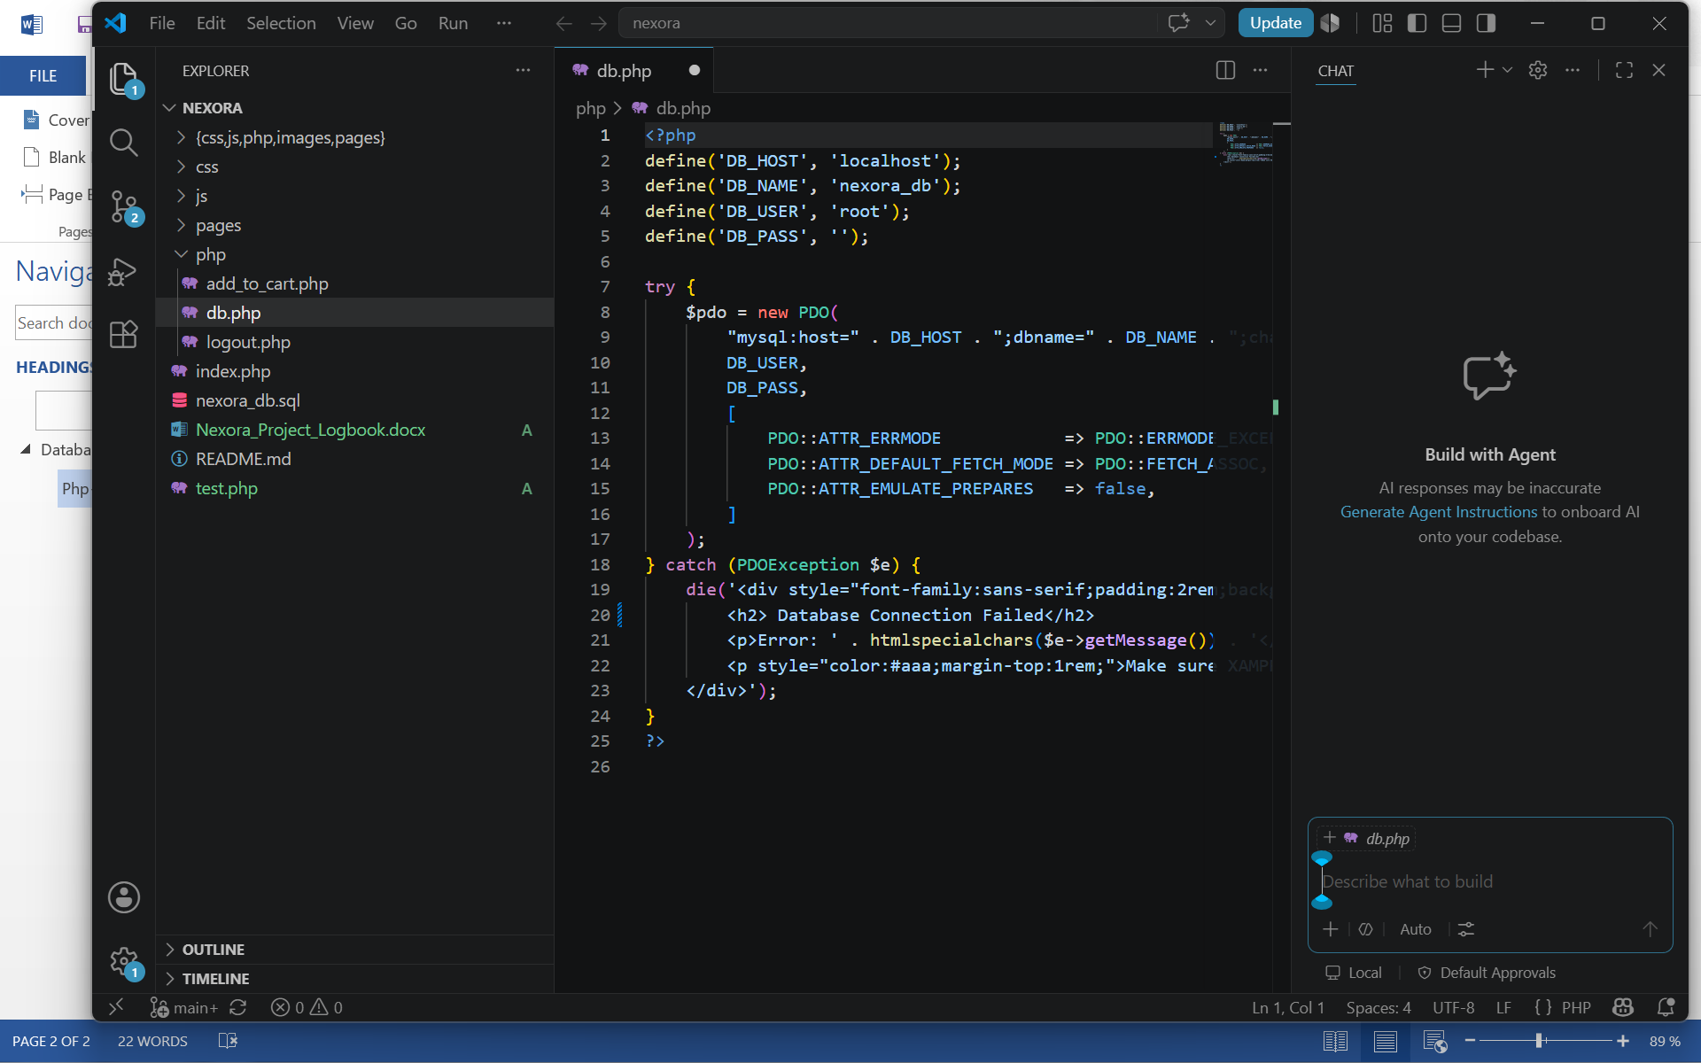
-The figure below showcases the tables list

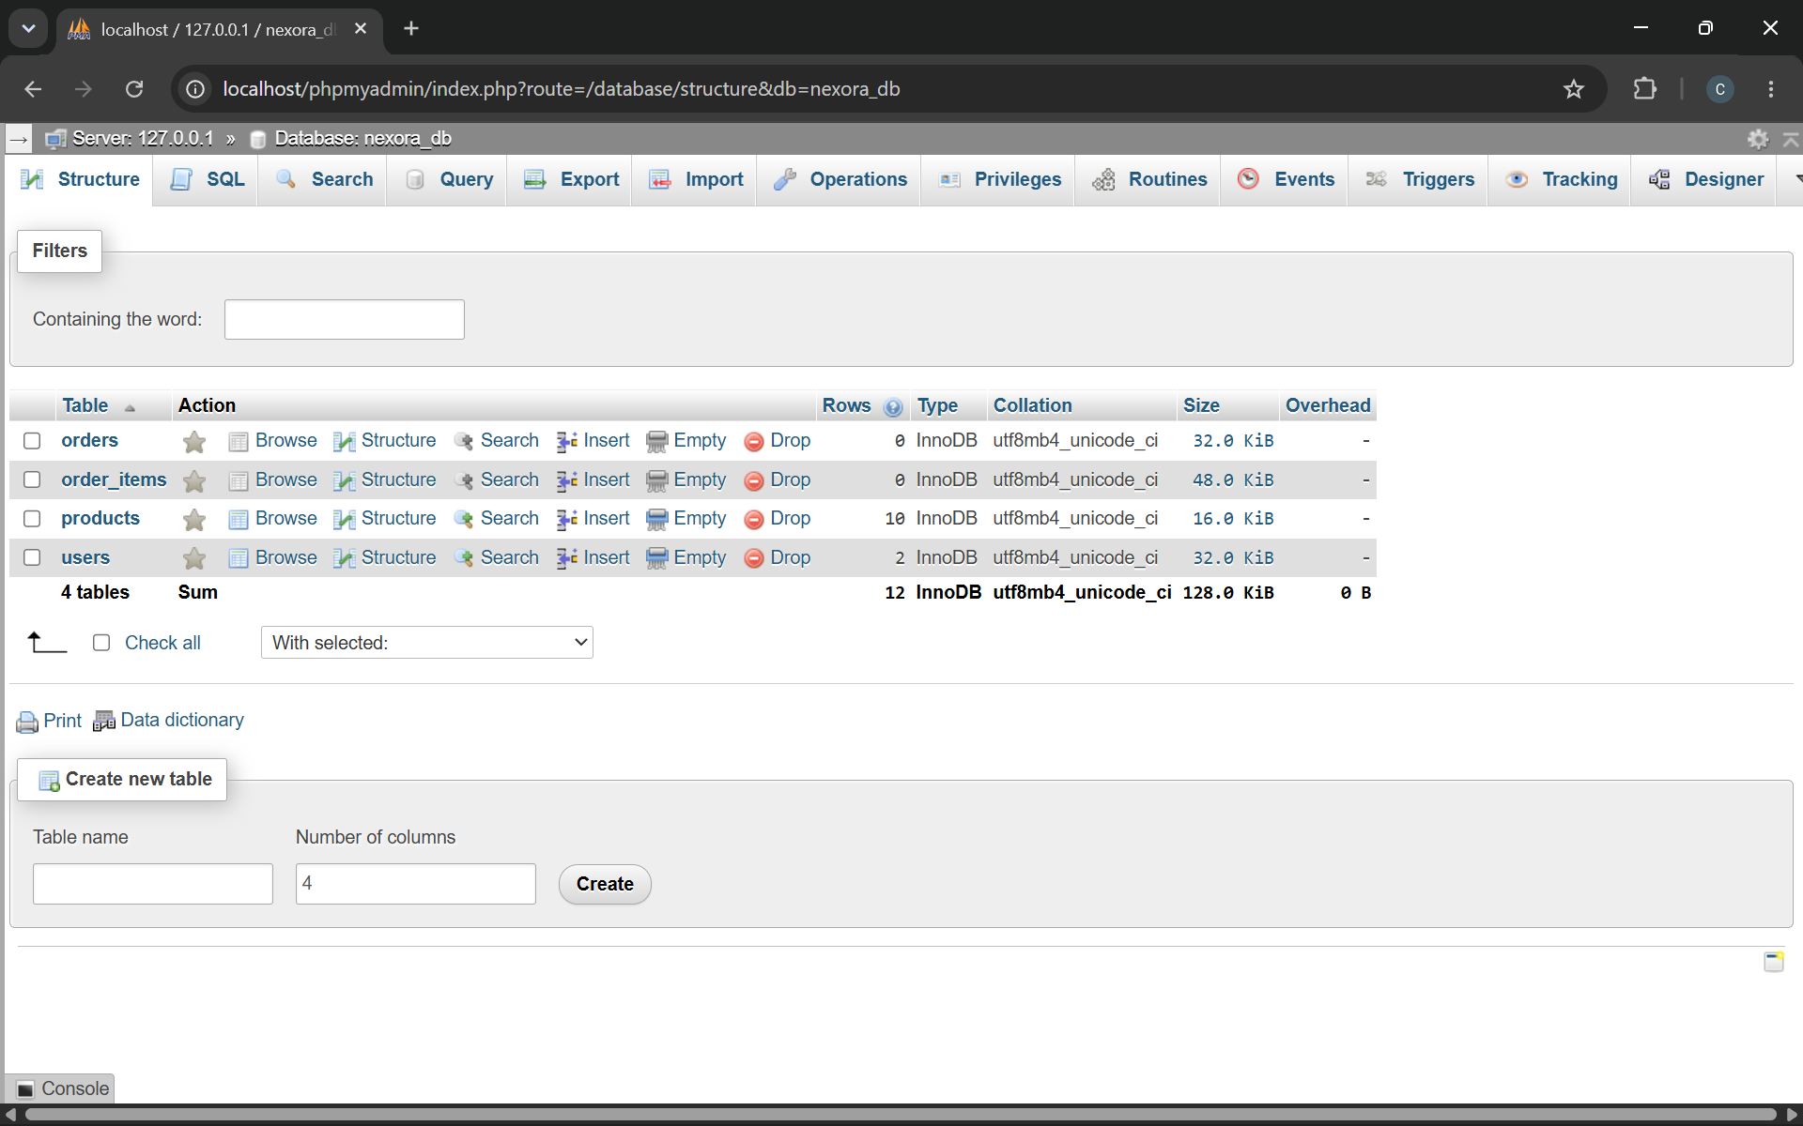
-The figure below showcases the products table structure
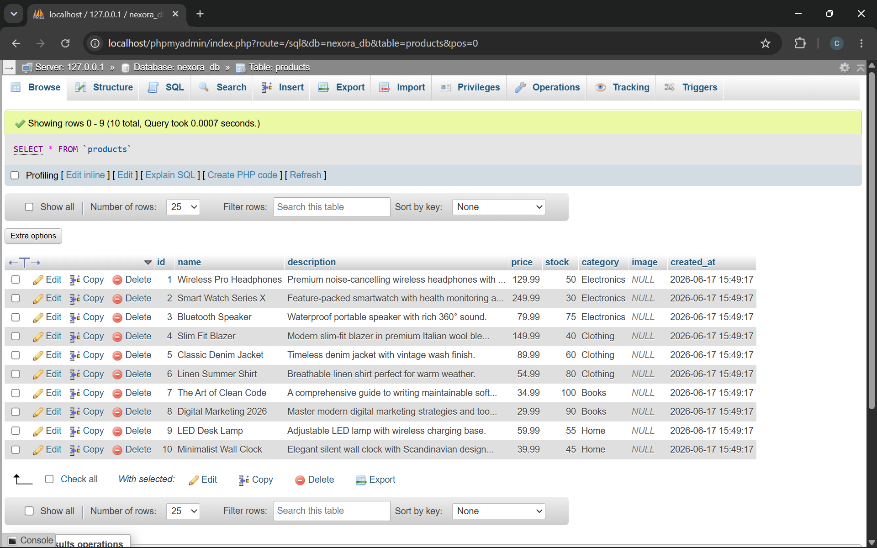

CRUD OPERATIONS

1.Create(Insert)operation
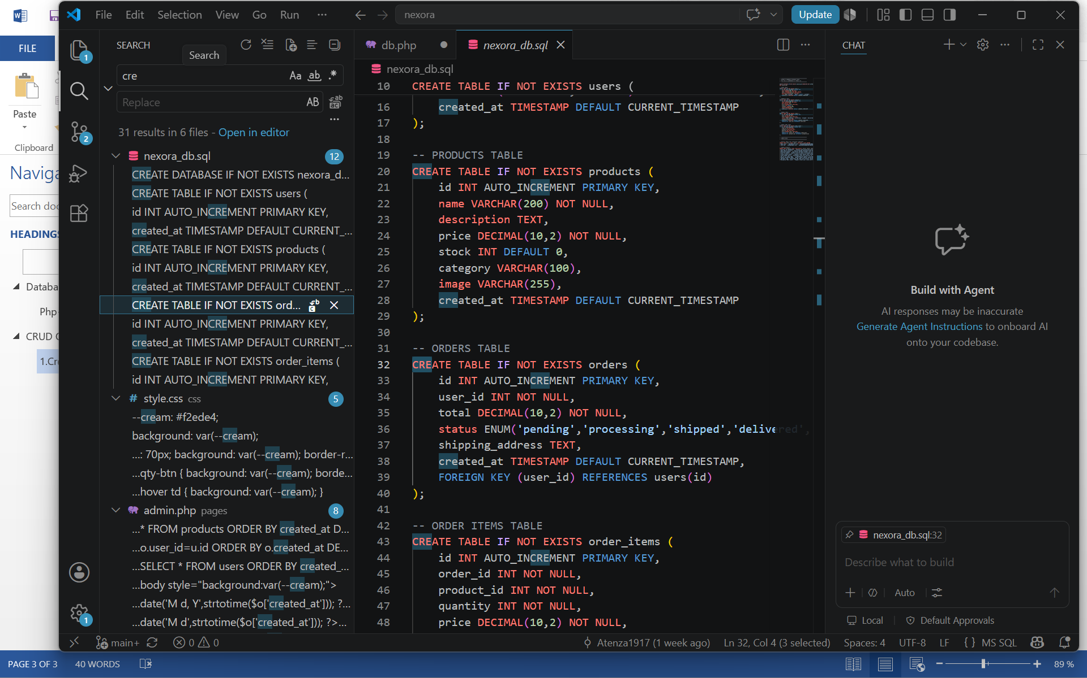
-The figure below shows the add new product section
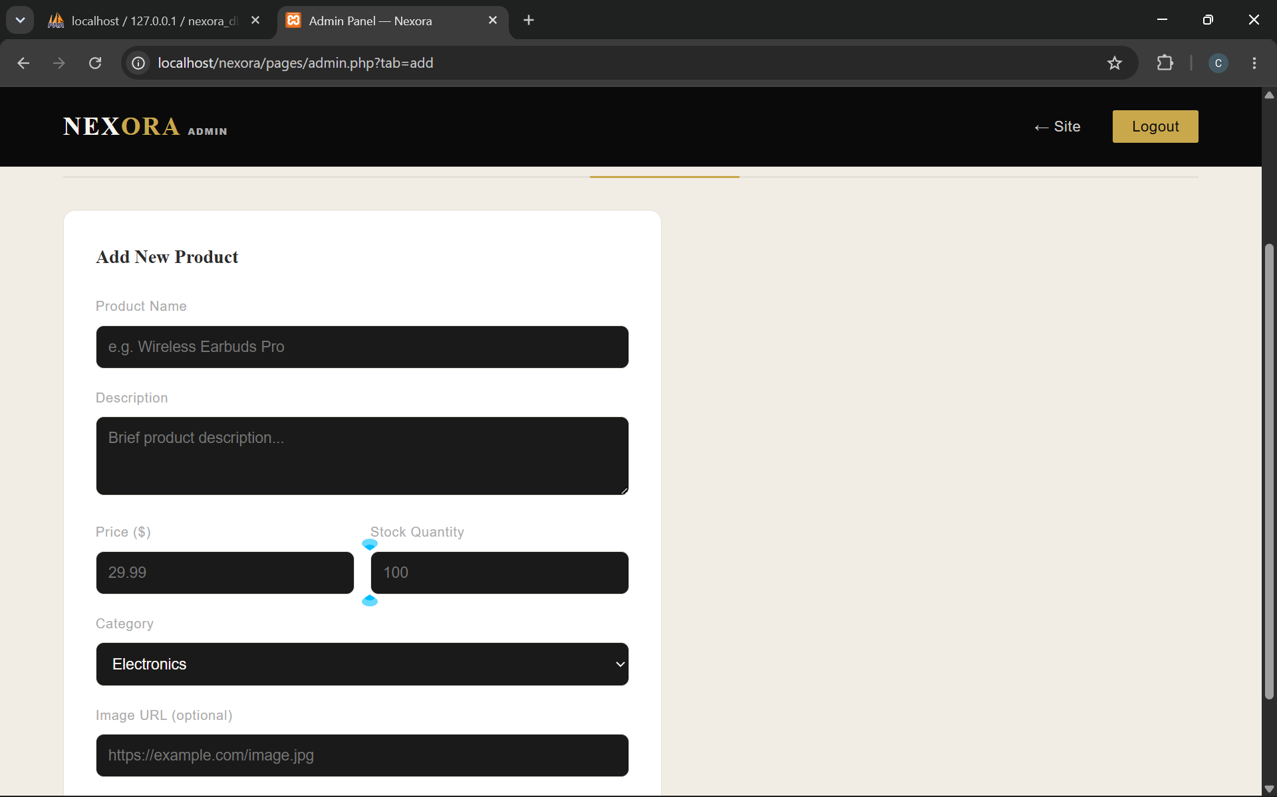

Read operations
-The script below showcases the read operation
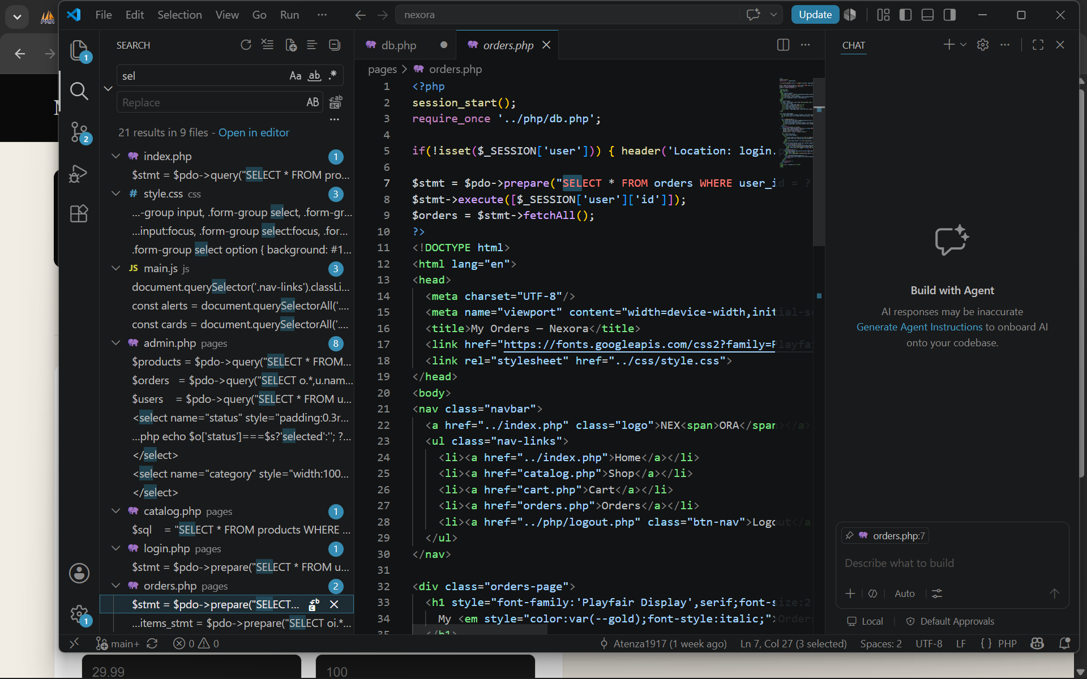
-The figure below shows the select products section

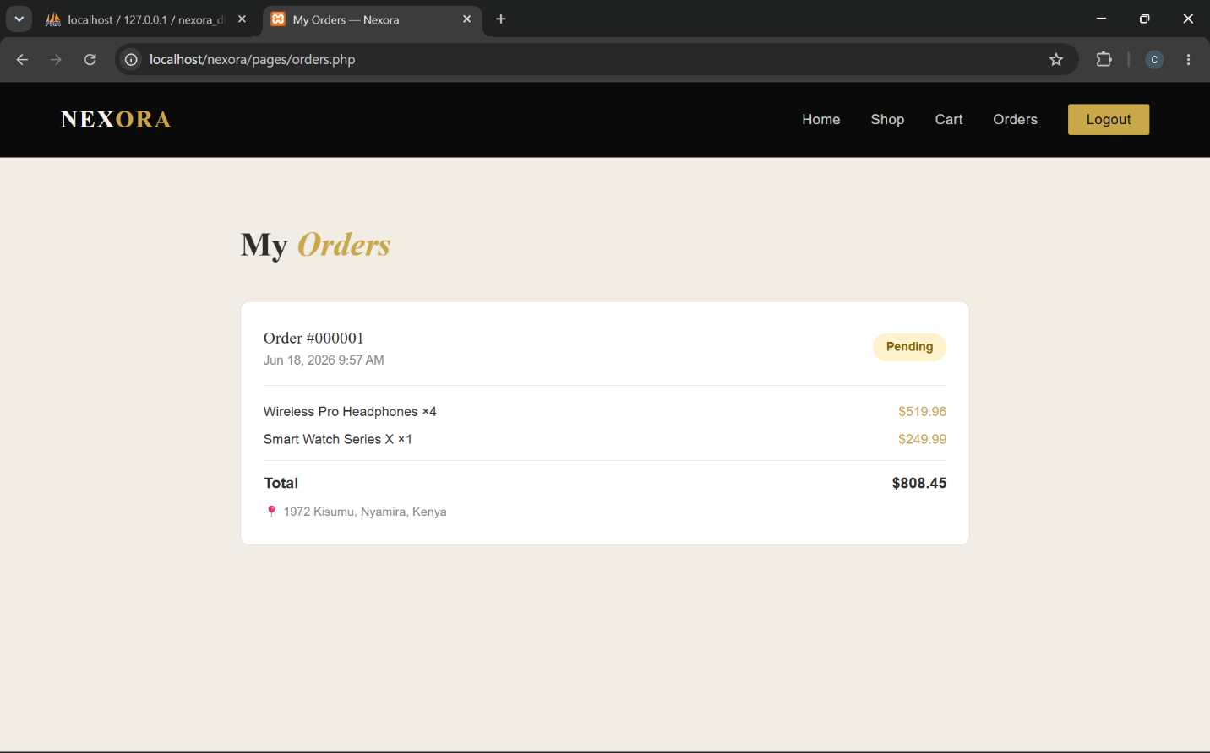

Update operations
-The code below showcases the update operations
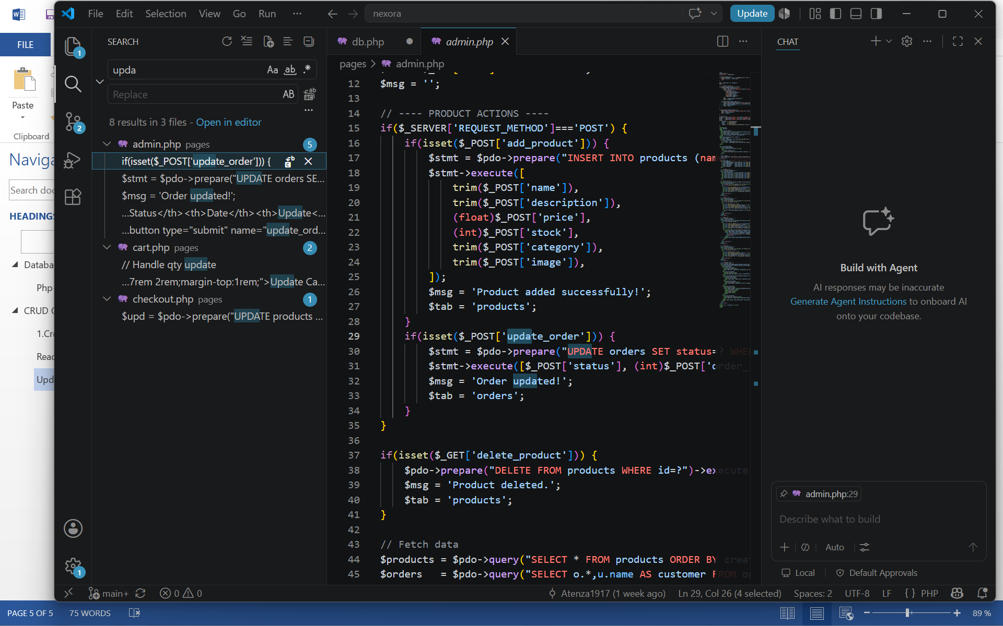
-Figure below illustrates how the update operation is present in the website
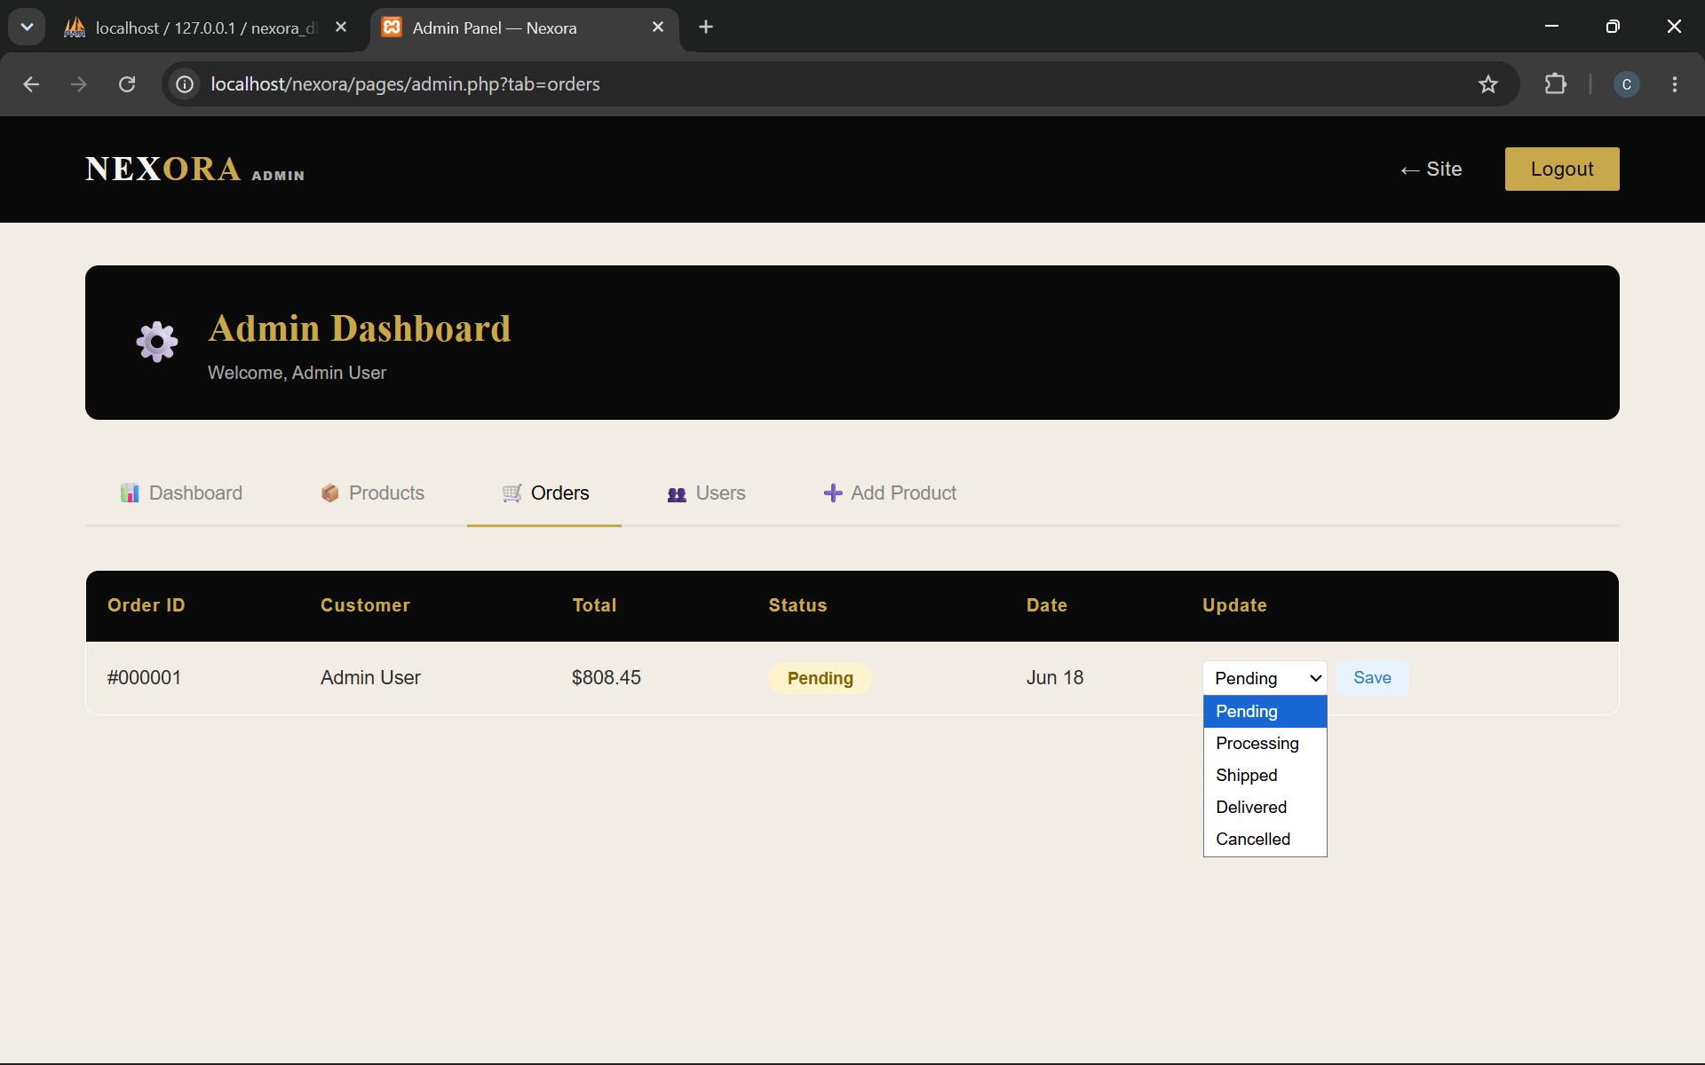

Delete operations
-The script below showcases the delete operations
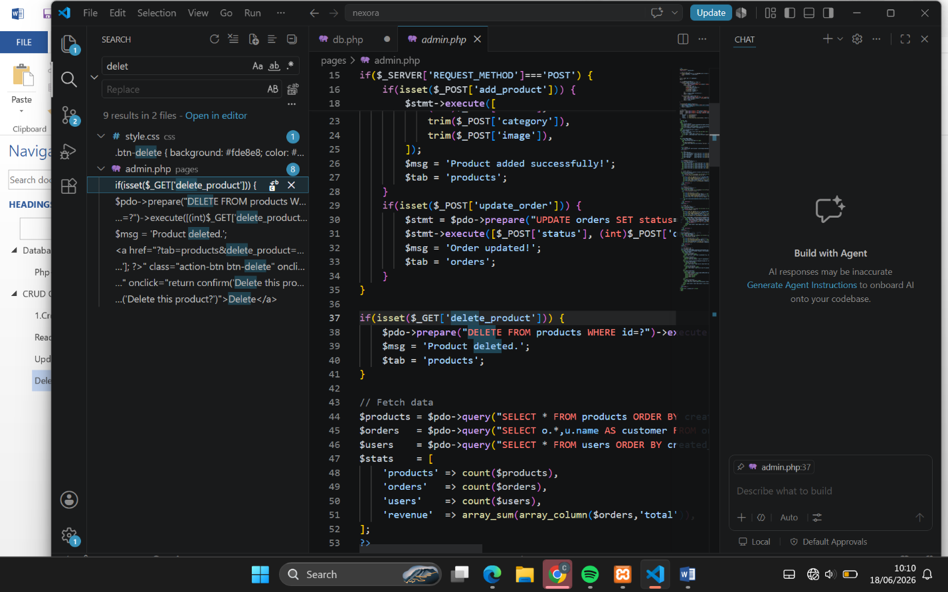
-The figure below illustrates the delete function in the website
